Project : Career Compass Roadmap Generator
(For 10th & 12th Pass Students)
Problem Statement
- Many students finishing 10th or 12th grade have a tough time deciding what to do next. They face choices like higher studies, vocational training, or direct jobs.
- Career advice often feels generic. It doesn’t take into account individual interests, strengths, or financial situations.
- Rapid changes in industry demand make it hard to figure out the right courses or skills.
- Without clear guidance, students may make poor career choices, wasting time and harming their chances of getting a job.
- A Career Compass Roadmap System is needed to offer personalized career paths for school leavers.
Underlying Factors
- Limited access to career counselling in schools.
- Lack of awareness of vocational and skill-based opportunities.
- Peer and parental pressure leads to uninformed decisions.
- Difficulty finding affordable and accessible learning paths.
Stakeholders
- Internal Users:
- Career Platform Administrator
- Development Team
- Career Counsellors
- Educational Institutions
- IT Support

- External Users:
- 10th Pass Students
- 12th Pass Students
- Parents/Guardians
- Teachers
- Vocational Training Providers
- Colleges/Universities
- Employers offering entry-level jobs

- Expected Users:
- High school graduates (10th pass)
- Senior secondary graduates (12th pass)
- Parents and guardians
- Career counsellors and mentors
- Training providers and institutions

Objectives
Provide personalized career roadmaps for 10th and 12th pass students.
Suggest suitable streams (Science, Commerce, Arts, Vocational) after 10th.
Recommend higher education, skill training, or job opportunities after 12th.
Identify skill gaps and suggest certifications or short-term courses.
Help students make informed career decisions early.
Improve employability and confidence in career planning.

Expected Outputs
- Personalized career roadmap (study path or vocational path).
- Recommended streams after 10th (Science, Commerce, Arts, Vocational).
- Suggested higher education courses after 12th.
- Skill gap analysis.
- Recommended certifications and training programs.
- Step-by-step learning plan.
- Career progression timeline.
- Downloadable career roadmap report.

Strategic Information
- Promote employability and skill development among youth.
- Reduce career confusion and dropouts.
- Align student choices with industry demand.
- Encourage vocational and technical education.

Tactical Information
- Monitor student interests and strengths.
- Recommend suitable streams and courses.
- Suggest affordable training options.
- Provide mentorship and counselling support.

Operational Information
- Student registration and login.
- Profile creation (marks, interests, career goals).
- Career roadmap generation.
- Course and training recommendations.
- Progress tracking.
- Notifications and reminders.
Feasibility Study
Technical Feasibility:
- Can be developed using HTML, CSS, JavaScript, PHP, and MySQL.
- Integration with APIs for training providers and colleges.
- Real-time analytics achievable.
Economic Feasibility:
- Low development cost using open-source technologies.
- Affordable maintenance.
- Reduces reliance on costly career counselling.
Operational Feasibility:
- Simple and user-friendly for students and parents.
- Easy adoption by schools and training providers.
- Improves efficiency in career decision-making.

Requirements
Functional Requirements :
- Student Registration and Login
- Profile Management (marks, interests, goals)
- Career Roadmap Generation
- Stream Recommendation (after 10th)
- Course Recommendation (after 12th)
- Skill Gap Analysis
- Training/Certification Suggestions
- Mentor/Counsellor Matching
- Report Generation
- Notification and Alert System
Non-Functional Requirements :
- User-friendly interface
- Fast response time
- High availability
- Data security and privacy
- Scalability
- Responsive design

User Activities
USERS
- System Administrator
- Students-10th and 12th pass
- Carrer Councillors
- School/College Admin
- Industry Trainer
System Administrator:
      - Manage user accounts and roles.
      - Add, update, or remove users.
- Monitor overall system performance.
- Manage databases and system security.
- Configure system settings.
- Manage Subscription.
- Run Advertisements.
- Handle backups and data recovery.
- Monitor system usage and logs.
- Generate system-wide reports.
- Resolve technical issues and ensure smooth operation.

10th Pass Student:
- Register and log in to the system.
- Create and update personal profile.
- Enter academic performance and interests.
- Take aptitude and personality assessment tests.
- Explore suitable streams (Science, Commerce, Arts, Vocational).
- Receive stream recommendations based on interests and skills.
- View future career opportunities related to each stream.
- Explore skill-development activities and learning resources.
- Set short-term academic goals.
- Track progress and assessment results.
- Request for career counselling.
- Switch to premium mode for face-to-face chat with the career councillors.
- Communicate with career counsellors.
- Download career guidance reports.

12th Pass Student:
- Register and log in to the system.
- Create and update profile with Class 12 academic details.
- Enter preferred career fields and higher education interests.
- Take advanced career aptitude assessments.
- Explore degree courses and professional programs.
- Receive personalized career roadmap.
- View recommended colleges, universities, and entrance exams.
- Explore certifications and skill-development courses.
- Track career preparation progress.
- Switch to premium mode for face-to-face chat with the career councillors.
- Connect with career counsellors and industry trainers.
- Set long-term career goals.
- Download career roadmap and career reports.
School/College Admin:
- Log in to the system.
- Manage student accounts and records.
- Monitor student participation and progress.
- Generate institutional reports and analytics.
- Switch to premium mode for face-to-face chat with the career councillors.
- In premium mode school and college can coordinate with career counsellors and trainers.
- Organize career guidance events and workshops.
- View career outcome statistics of students.
- Manage academic information and departments.
- Approve institutional activities related to career planning.
Career Counsellors:
- Log in to the system.
- Give your personal details.
- Give your expertise details.
- Choose your desired stream.
- View student profiles and assessment results.
- Analyse student strengths, weaknesses, and interests.
- Provide career guidance and recommendations.
- In premium mode provide customised reports to principal/teacher/parents/students.
- Modify or approve generated career roadmaps.
- Schedule counselling sessions.
- Answer student queries and provide feedback.
- Monitor student career progress.
- Generate counselling reports.

Industry Trainers:
- Log in to the system.
- Give your personal details.
- Give your expertise details.
- Choose your desired stream.
- Add and manage industry-relevant courses and training programs.
- Upload learning materials and resources.
- Suggest certifications and skill-development paths.
- In premium mode provide customised reports to principal/teacher/parents/students.
- Review student skill gaps.
- Provide industry insights and career trends.
- Track learner participation in training programs.
- Update training content based on industry requirements.
Ethical Measures
User Ethics: Provide accurate academic information, respect privacy, avoid misuse.
Business Ethics: Ensure transparency in recommendations, equal service to all students.
Regulatory Ethics: Follow education and training regulations.
Data & Privacy: Secure login, encryption, user consent for data collection.
AI & Technology: AI-assisted career matching, unbiased recommendations, secure data handling.
Development Ethics: Create secure, reliable software, with proper testing, bug fixes, and documentation.

Data Science Activities
Descriptive Analysis:
- Number of students by stream choice.
- Most popular courses after 12th.
- Skill gaps by industry.
Diagnostic Analysis:
- Why some streams are chosen more.
- Why students struggle to progress in certain courses.
- Why vocational training is underutilized.
Predictive Analysis:
- Predict demand for streams (Science, Commerce, Arts).
- Predict future skill demand by industry.
- Predict student success rates based on roadmap adherence.
Prescriptive Analysis:
- Recommend targeted courses.
- Suggest vocational training programs.
- Advise career transitions.
- Recommend internships/projects.

USE CASE DIAGRAMS OF ALL USERS
Student
The primary user of the system. Students create profiles, take assessments, explore career options, receive personalized career roadmaps, track progress, enrol in courses, and interact with counsellors and industry mentors.
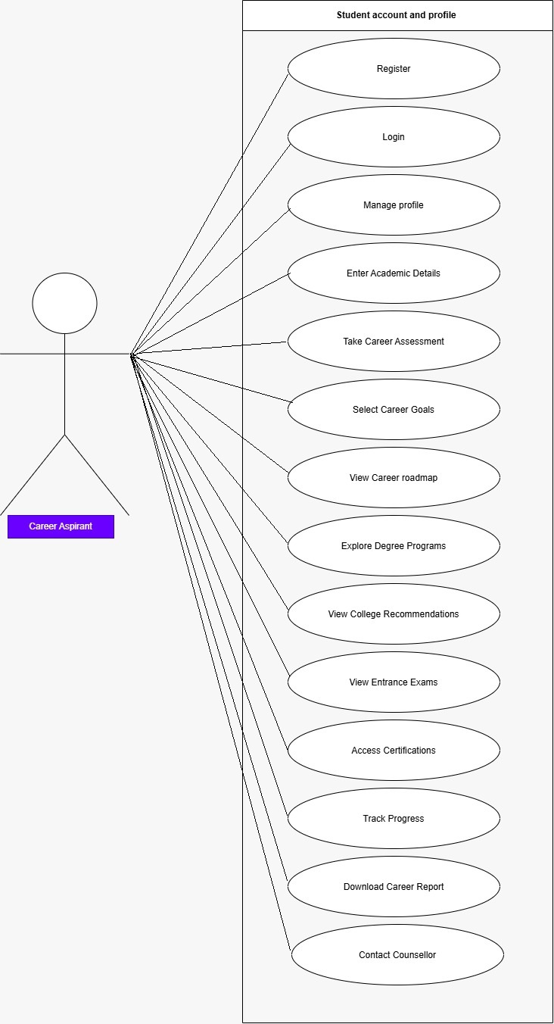

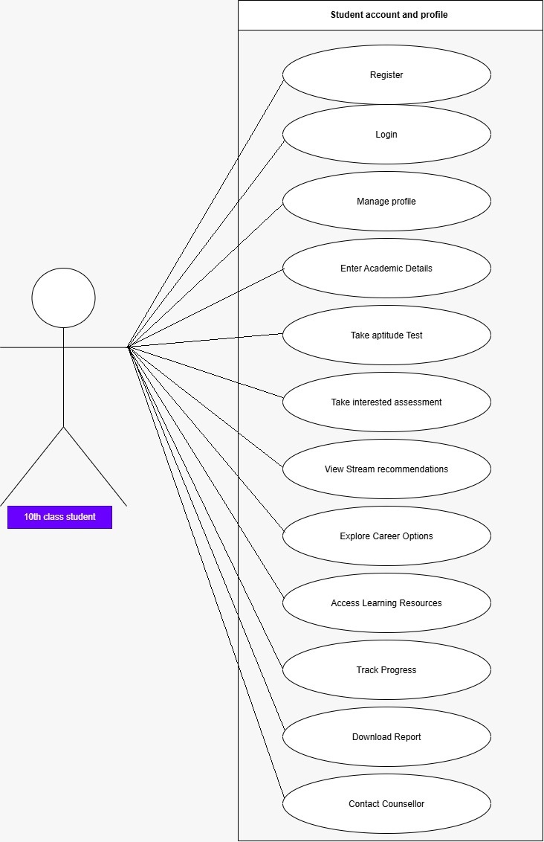
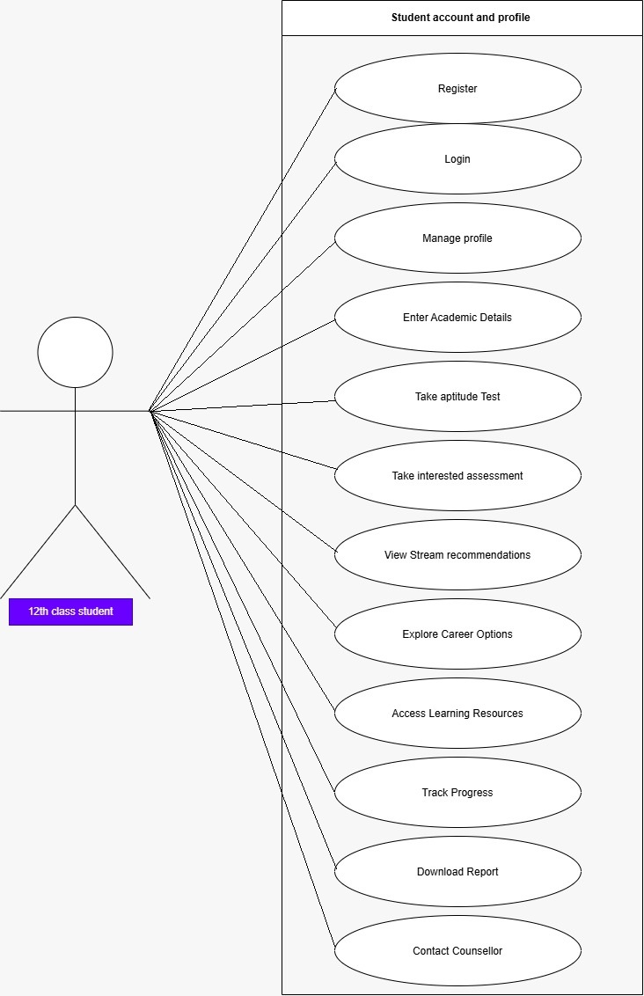

Counsellor
A professional who guides students in making informed career decisions. The counselor analyzes student assessments, reviews career plans, provides recommendations, and monitors student progress.
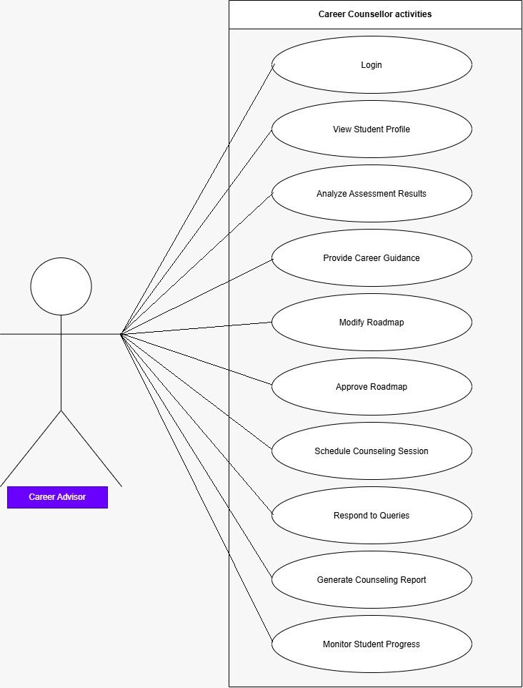
Trainer
Industry experts who provide practical knowledge, training programs, mentorship, and insights about current job market requirements
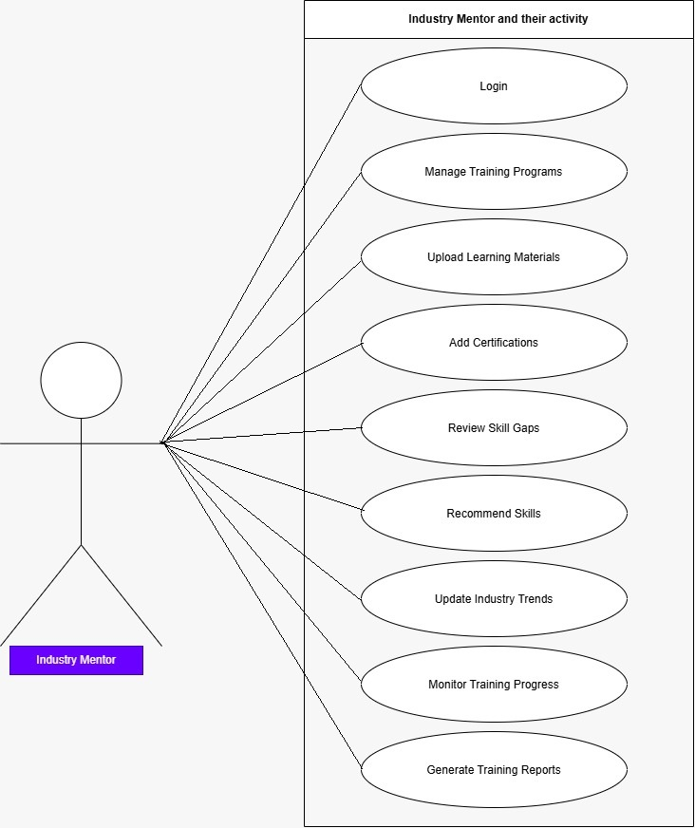
School/ college admin
Institution representatives who manage students and counsellors within their institution and monitor career development activities
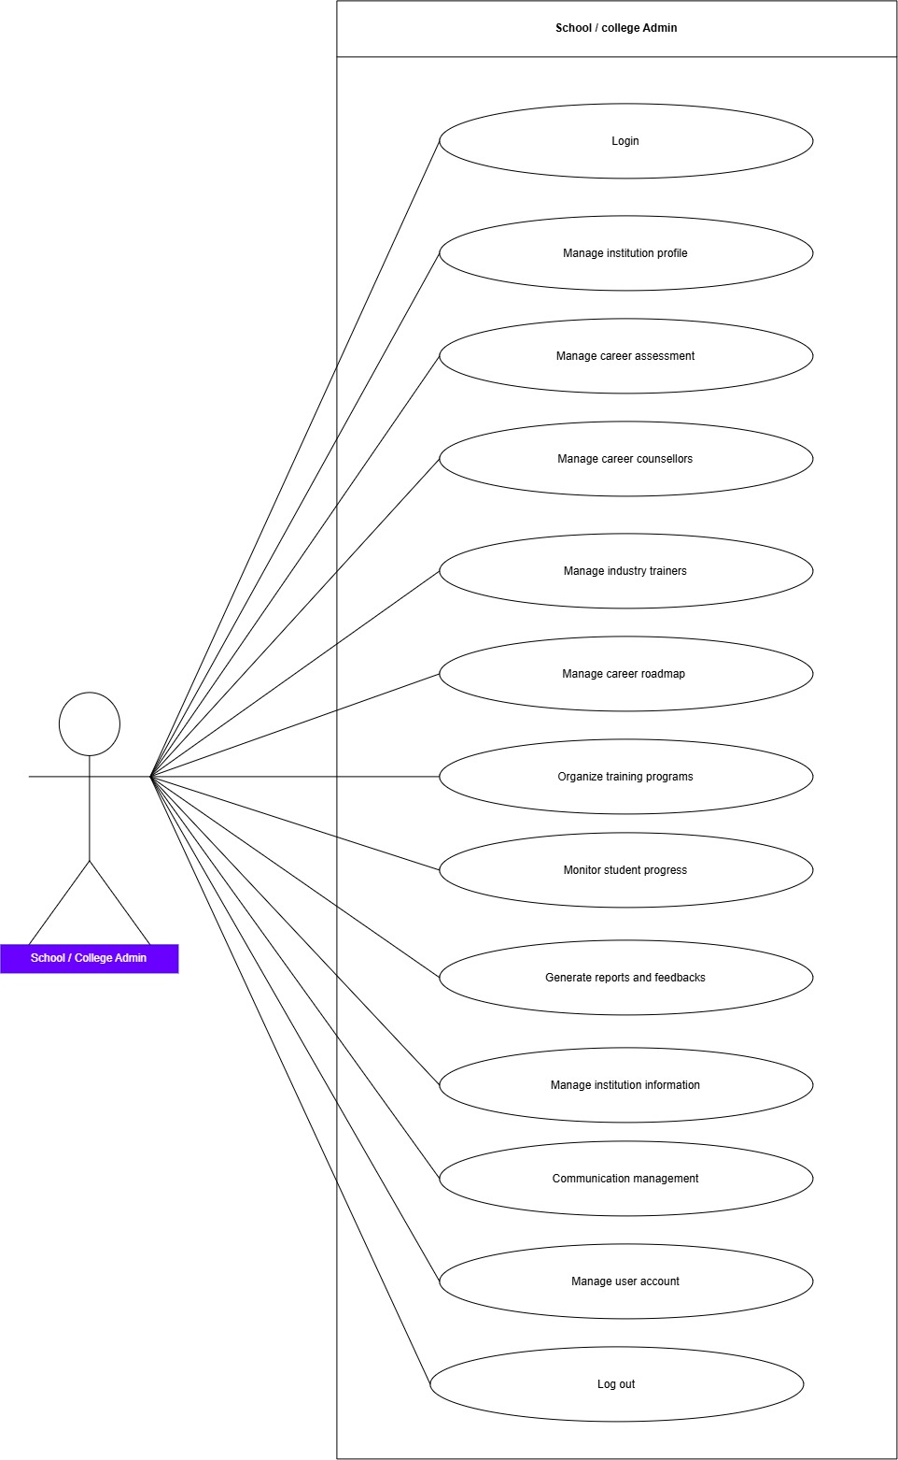
System Admin
The highest-level authority responsible for managing the entire platform, users, security, and system operations.
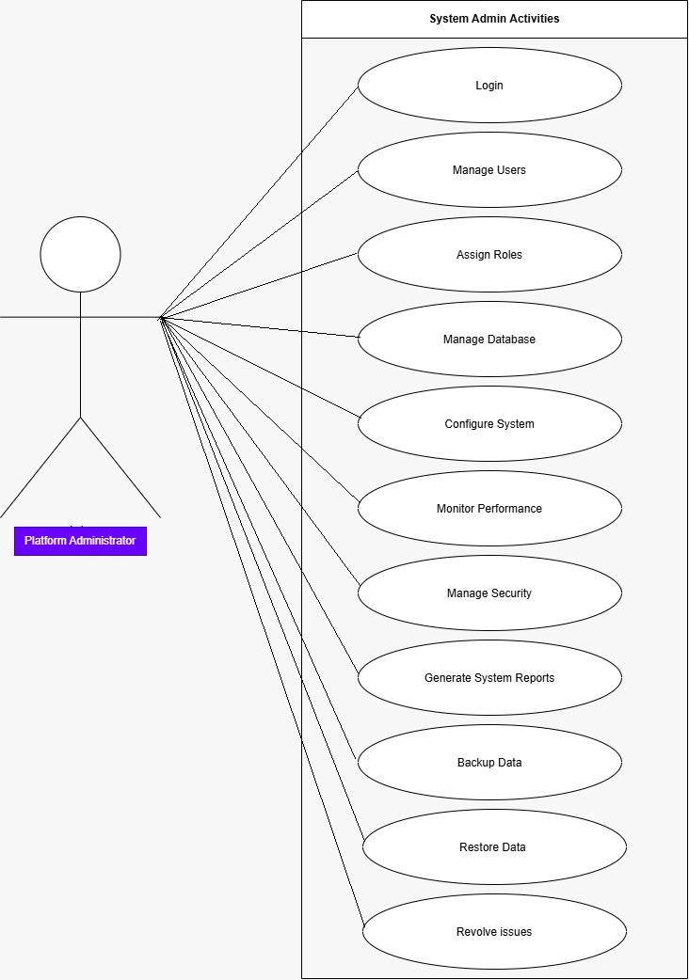
ACTIVITY DIAGRAM OF ALL USERS
Student
The Student is the primary user of the Smart Career Roadmap Generator. The student registers on the platform, completes career assessments, explores career options, receives personalized roadmaps, tracks progress, and interacts with counsellors and industry trainers to achieve career goals.
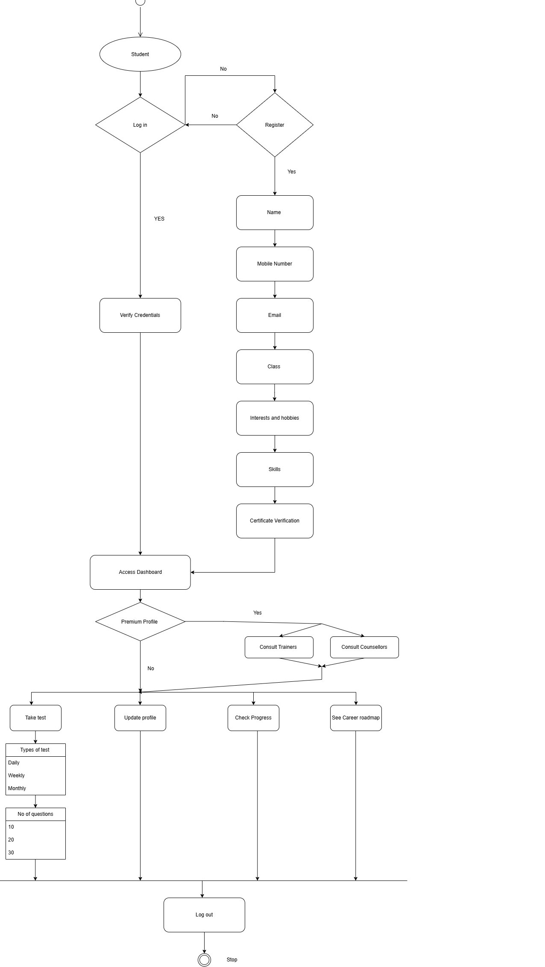
Counsellor
The Career Counsellor guides students in selecting suitable career paths. The counselor reviews student profiles and assessment results, provides personalized recommendations, monitors progress, and helps students make informed career decisions.
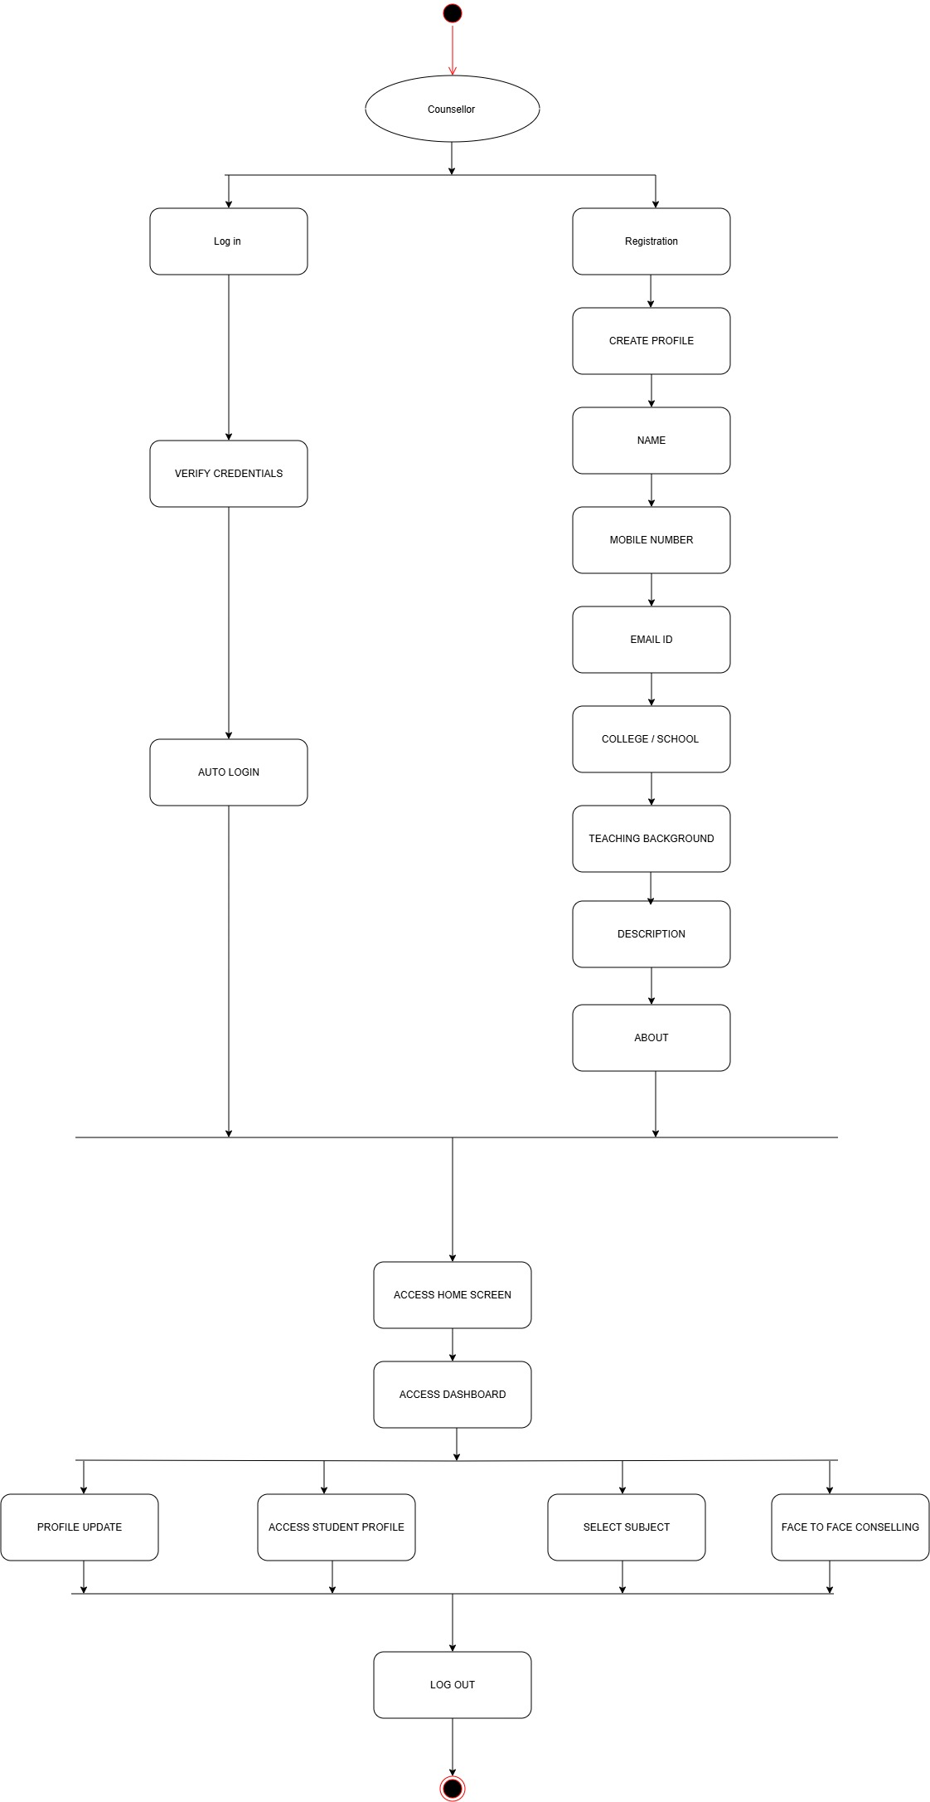
Industry Trainer
The Industry Trainer provides practical industry knowledge, training programs, mentorship, and skill-development opportunities. Trainers help students understand current industry requirements and prepare for future job roles.
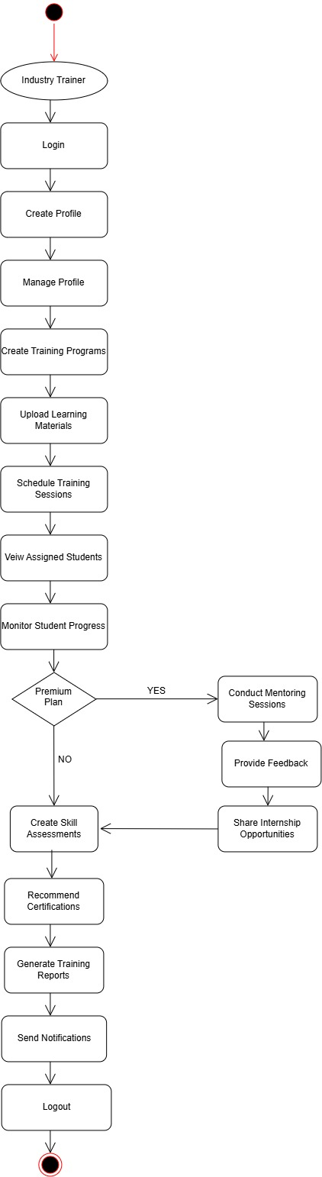
School/College Admin
The School/College Admin manages institutional activities on the platform. The admin oversees student registrations, assigns counsellors, monitors participation, organizes career development activities, and generates institution-level reports.
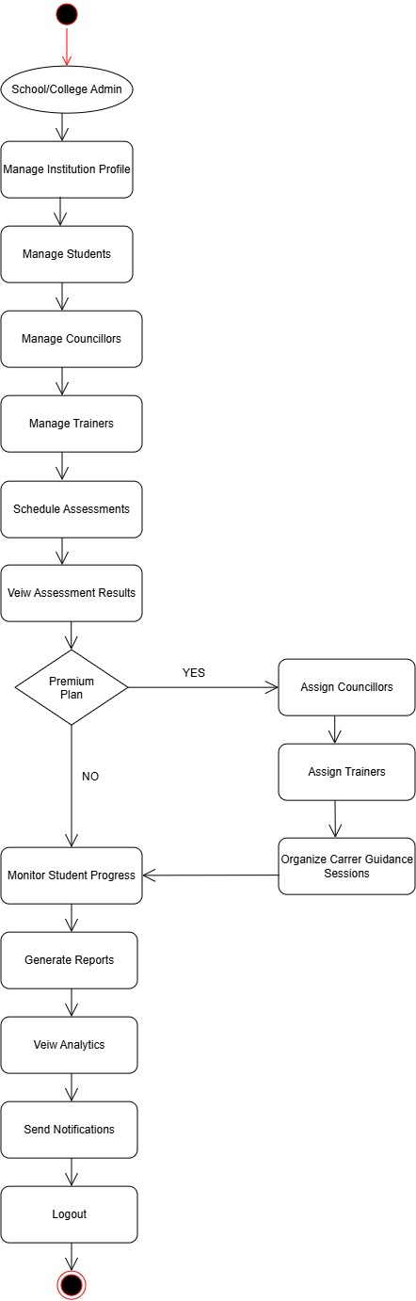
System Admin
The System Administrator manages the overall platform, including user accounts, security settings, system configurations, reports, and maintenance. The administrator ensures smooth and secure operation of the system.
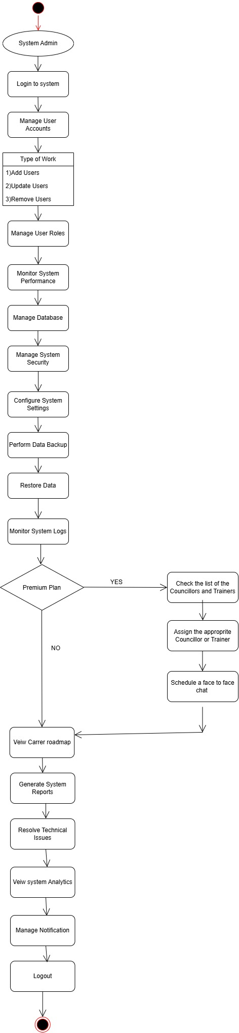
SEQUENCE DIAGRAM OF ALL USERS :-
Student
This sequence diagram illustrates how a student interacts with the Smart Career Roadmap Generator system. It shows the flow of actions such as registration, login, completing assessments, receiving AI-generated career recommendations, viewing personalized roadmaps, and tracking career progress.
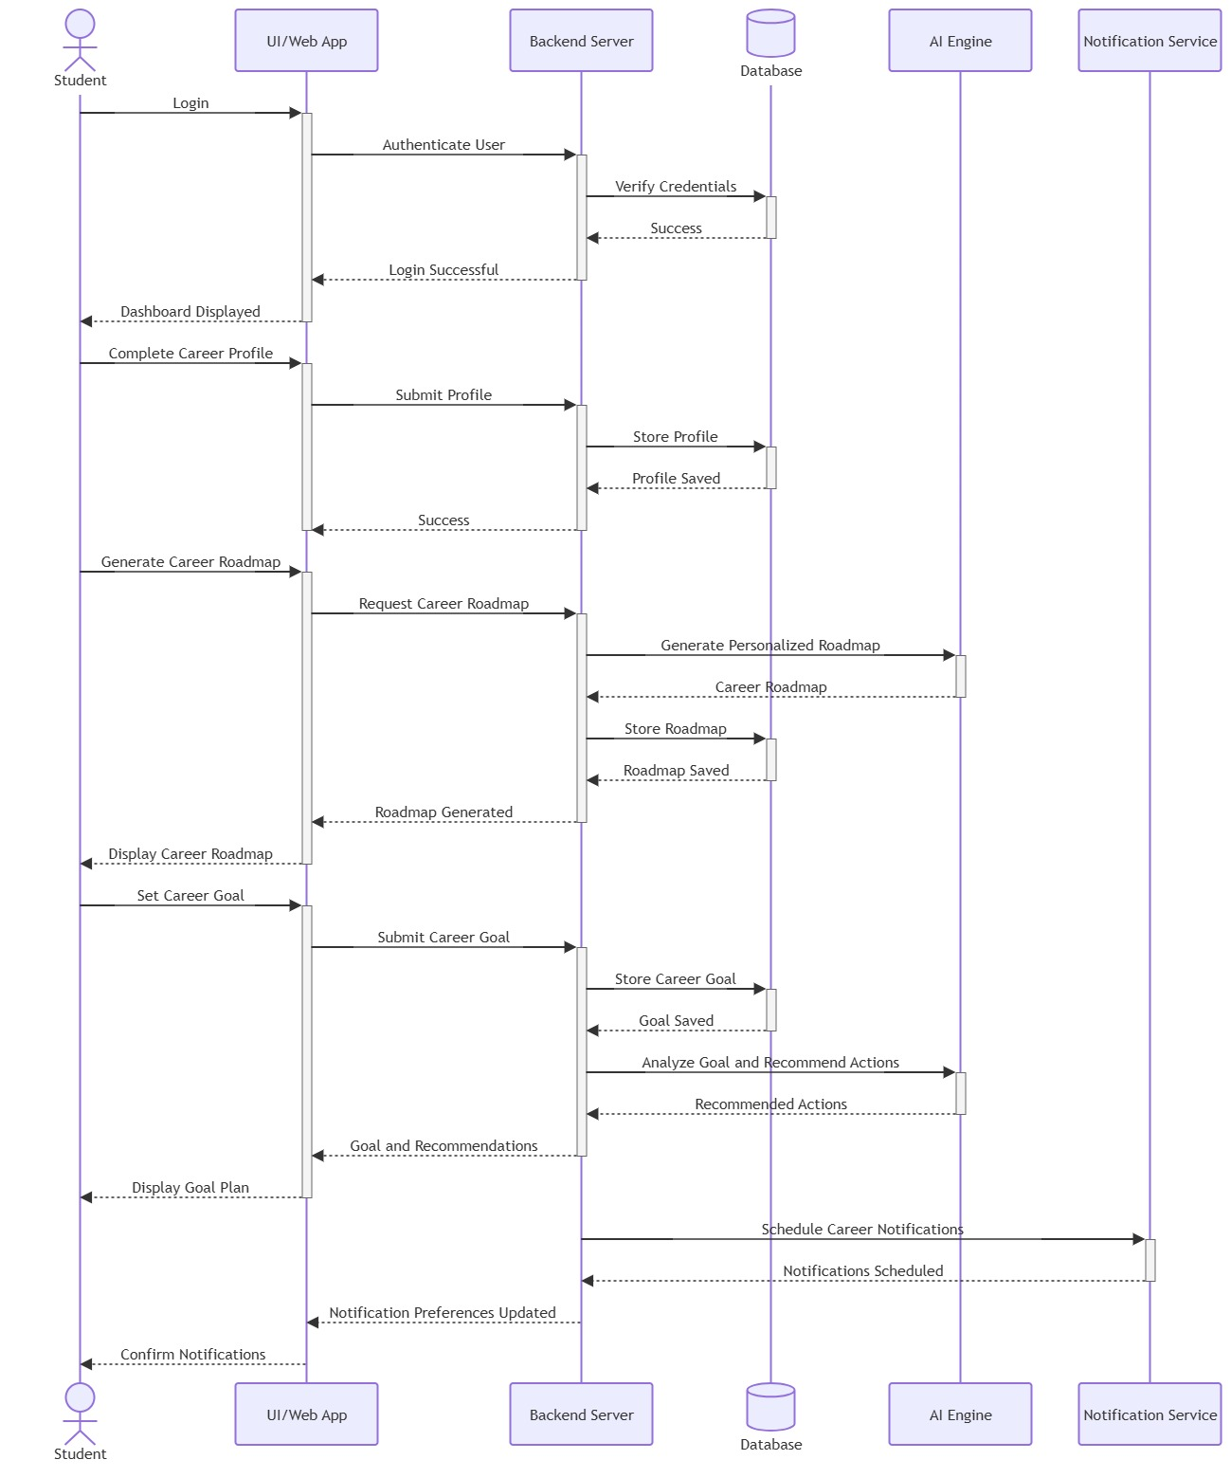
Counsellor
This sequence diagram illustrates how a career counsellor interacts with the system to review student profiles, analyse assessment results, provide career guidance, recommend learning resources, and monitor student development
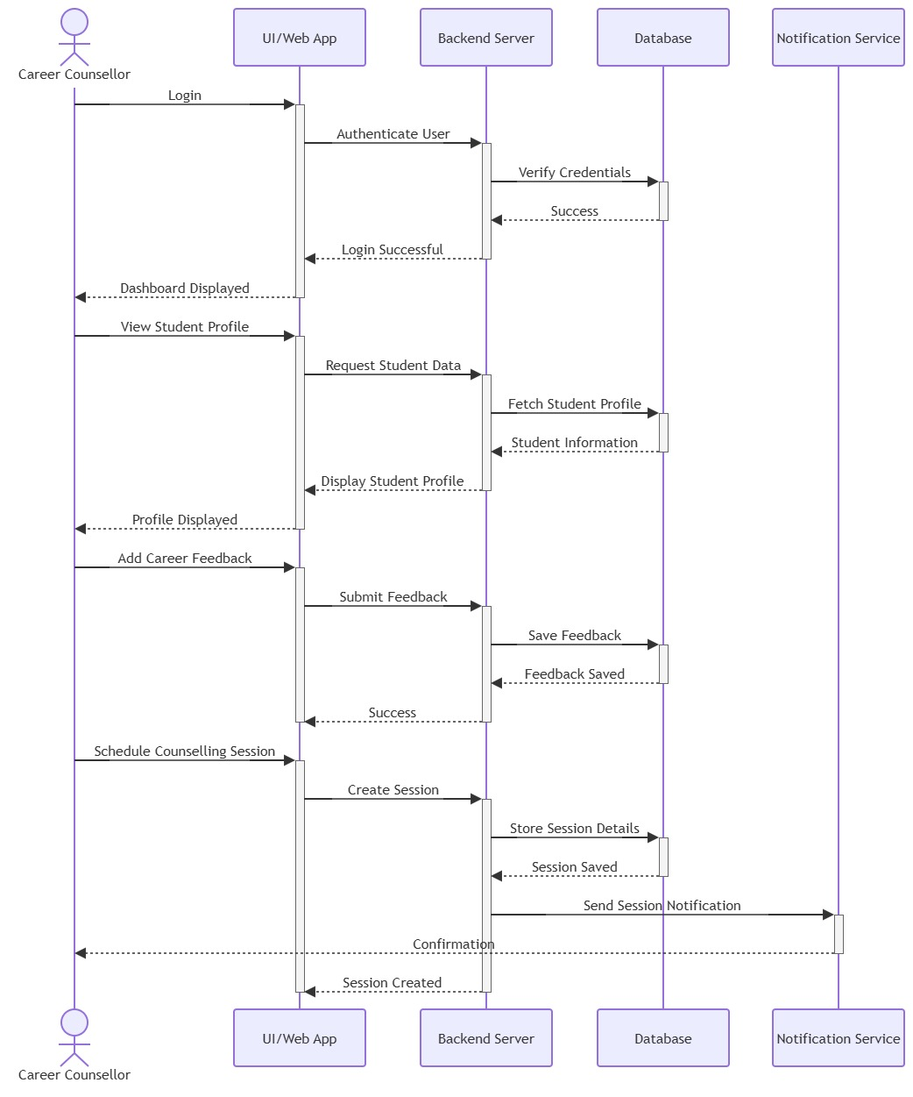
Industry Trainer
This sequence diagram illustrates how an industry trainer interacts with the system to create training programs, upload learning materials, mentor students, evaluate projects, and provide industry-specific recommendations.
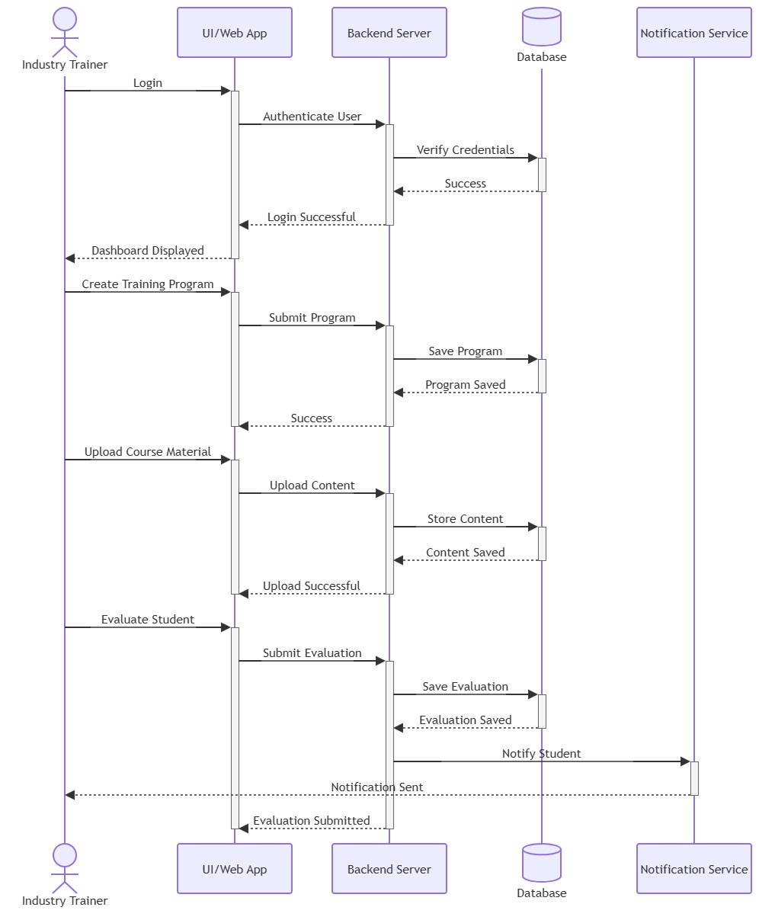
School/College Admin
This sequence diagram illustrates how a school or college administrator manages institutional activities through the system, including student management, counselor assignment, monitoring participation, organizing career events, and generating reports.
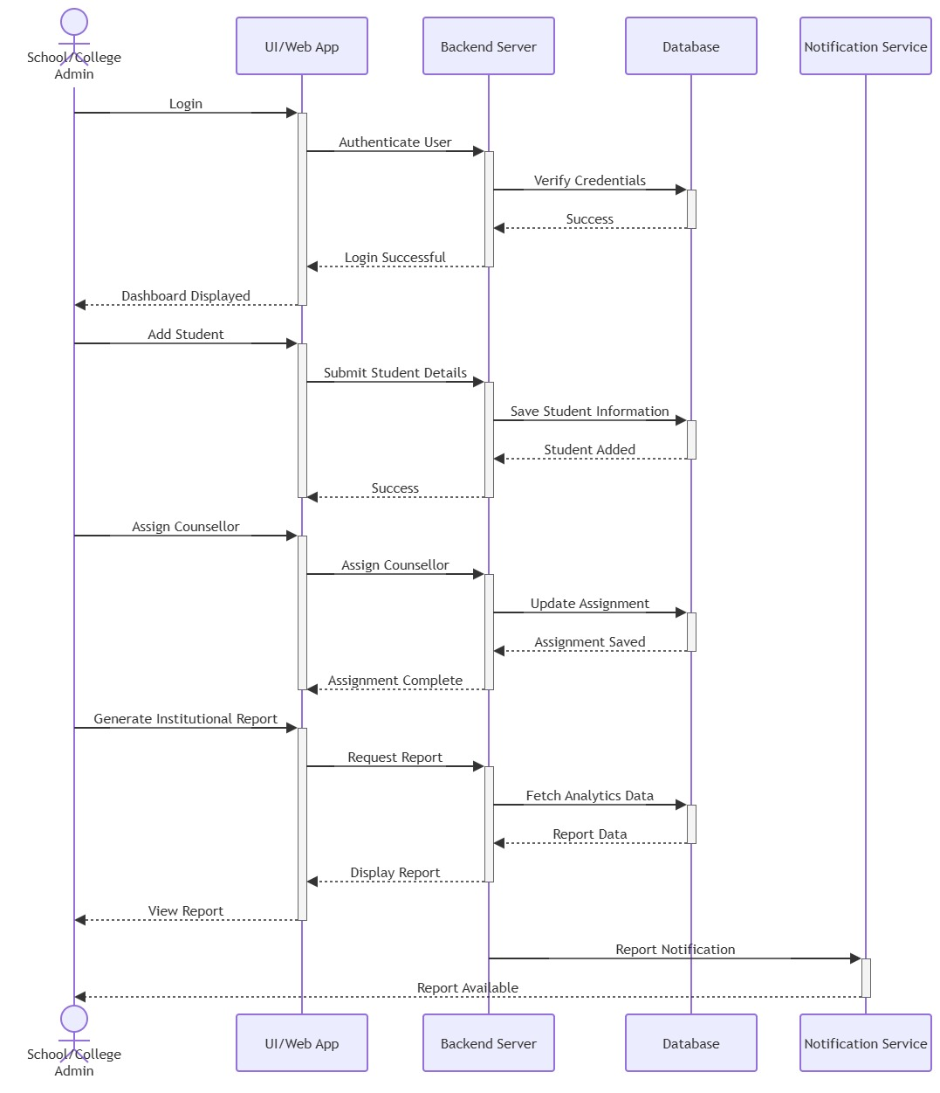

System Admin
This sequence diagram illustrates how the system administrator manages the overall platform by controlling user accounts, maintaining security, configuring system settings, monitoring performance, and generating system-wide reports.
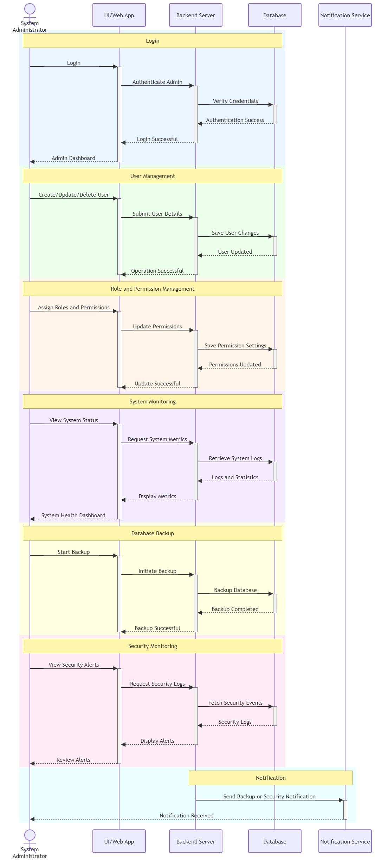
Sequence Diagram of Smart Career Roadmap Generator
This diagram represents the sequence of interactions and message exchanges between the actor and system components during the execution of a specific process.
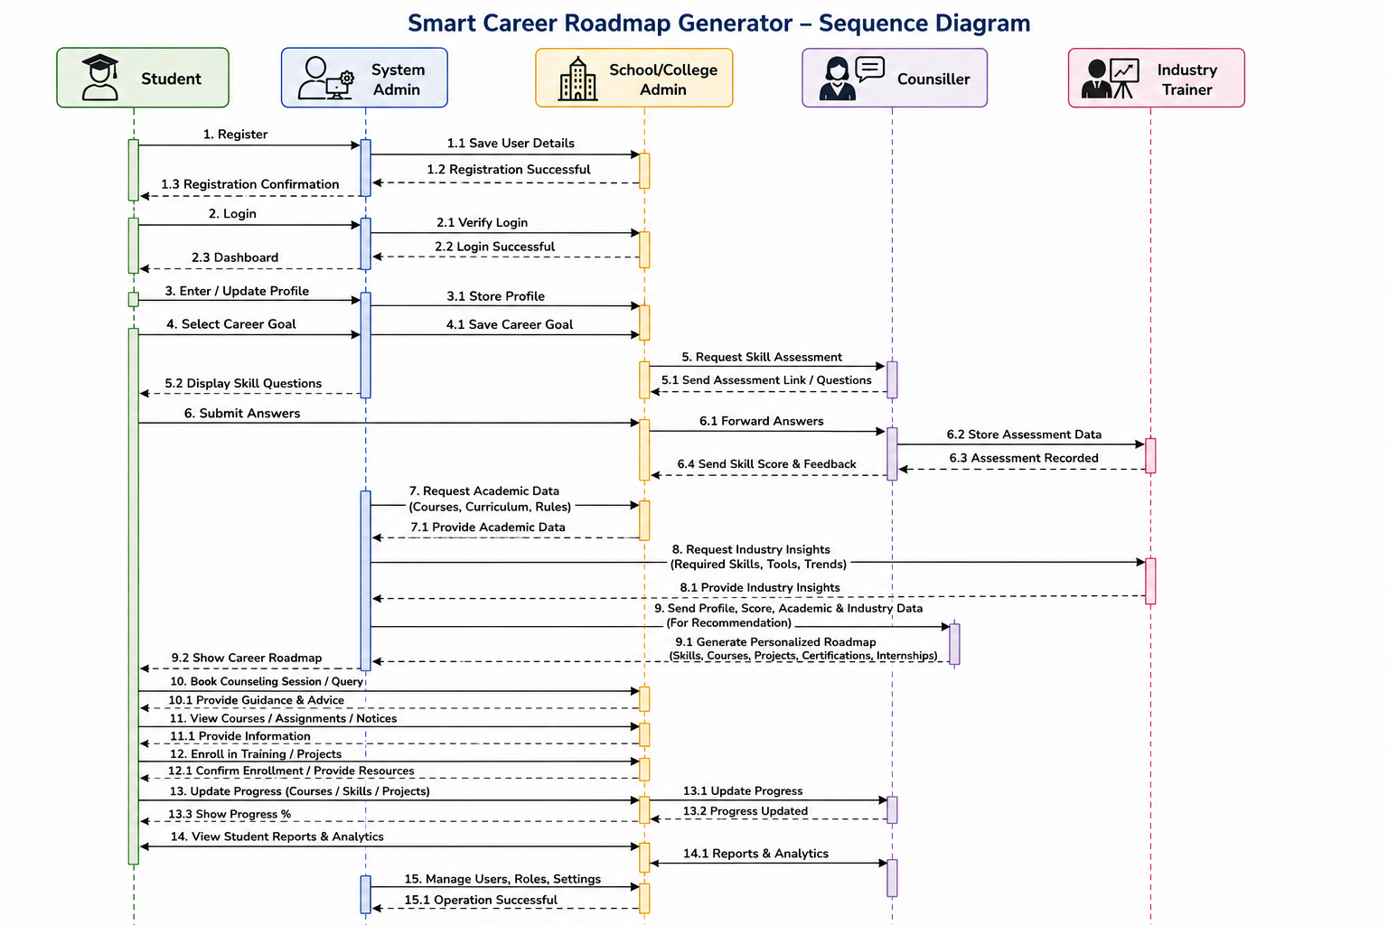
Database :-
The Smart Career Roadmap Generator Database is a relational database designed to manage students, career goals, skills, assessments, personalized roadmaps, academic information, industry training, and administrative activities. It connects students, school/college administrators, industry trainers, and system administrators through structured tables and relationships. The database enables efficient career planning, progress tracking, recommendation generation, and system management, ensuring accurate, secure, and organized data storage for the entire platform.
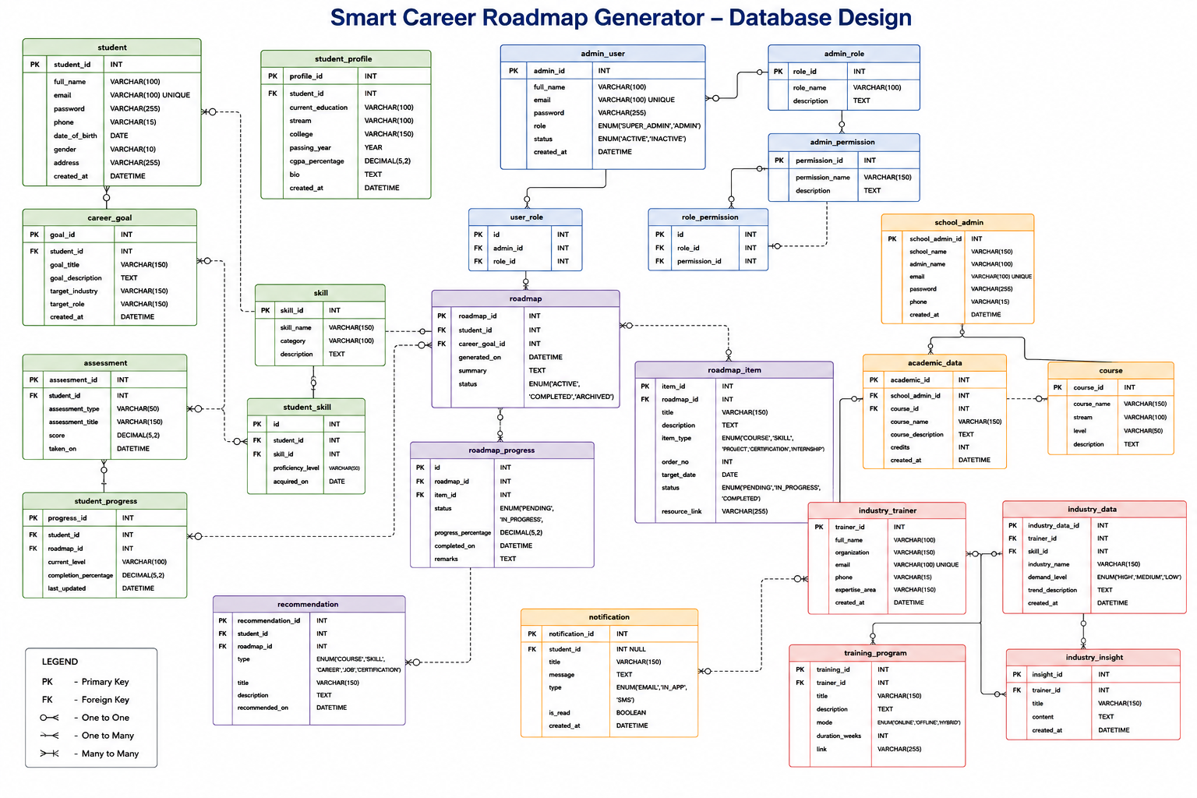

COLLABORATIVE DIAGRAM :-
This diagram shows how the actor collaborates and communicates with other system components to achieve a particular functionality within the Smart Career Roadmap Generator.
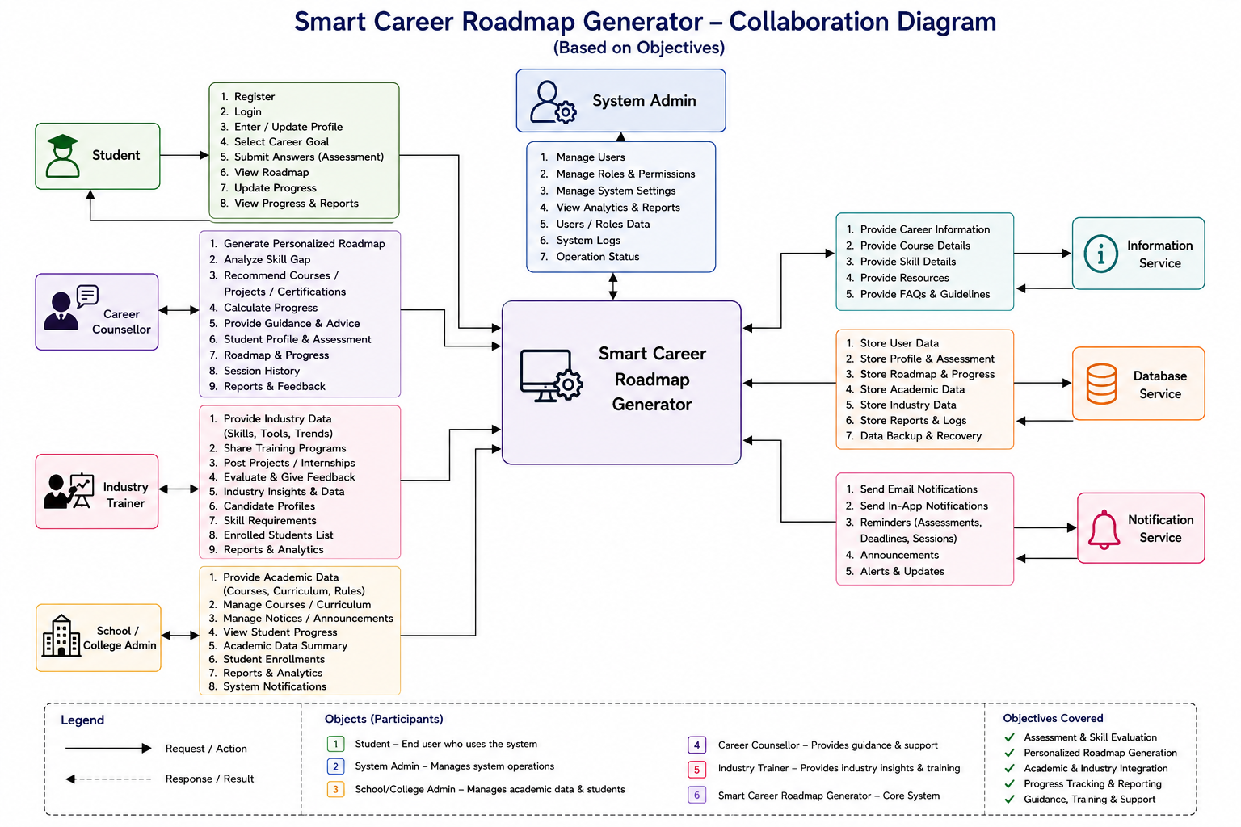

THANK YOU

